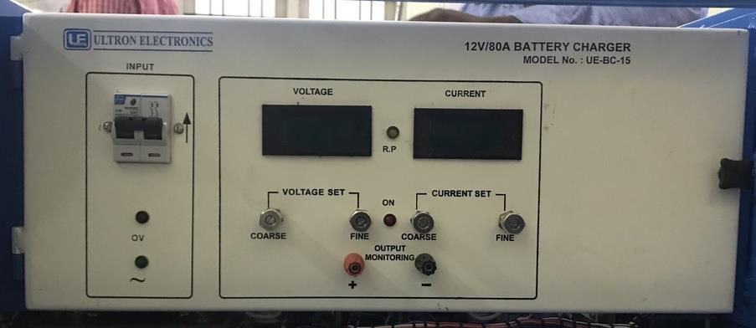

SPECIFICATIONS FOR 12V/80A BATTERY CHARGER

1. Model no : UE-BC-15.

2. Mains input : 230V, ±10%, 50Hz, Single phase.

3. Line Regulation : ±0.1% max. Output Voltage for ± 10% change
in mains Input Voltage.

4. Load Regulation : ±0.1% max. Output Voltage for No-load
to full load or Vice-versa.

5. Ripple : Less than 100mV R.M.S.

6. Protections : a) Unit is protected by input fuse,
b) Unit is protected against input surges,
c) Output is protected against over loads &
Continuous short circuits.

7. Indication(s) : a) One LED for input,
b) One LED each for output,
c) One 3½ digit digital panel meter is
provided to read output voltage,
d) One 3½ digit digital panel meter is
provided to read output current.

8. Controls : One ON/OFF switch to ON/OFF the Unit.

9. Mechanical : Bench top / 19” Rack Mounting as
Required by you.

10. Cooling : Forced air cooling.

11. Operating Environment : 0°C to +50°C

12. Terminals : Banana socket(s) at front panel.

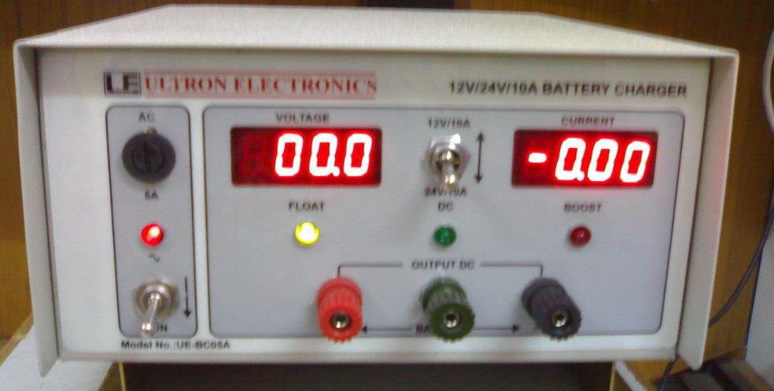

SPECIFICATIONS FOR 12V/24V/10A SMPS BATTERY CHARGER

1. Model no : UE-BC-05A.

2. Mains input : 230V, ±10%, 50Hz, Single phase.

3. Line Regulation : ±0.1% max. Output Voltage for ± 10% change
in mains Input Voltage.

4. Load Regulation : ±0.1% max. Output Voltage for No-load
to full load or Vice-versa.

5. Ripple : Less than 100mV R.M.S.

6. Protections : a) Unit is protected by input fuse,
b) Unit is protected against input surges,
c) Output is protected against over loads &
Continuous short circuits.

7. Indication(s) : a) One LED for input,
b) One LED each for output,
c) One 3½ digit digital panel meter is
provided to read output voltage,
d) One 3½ digit digital panel meter is
provided to read output current.

8. Controls : One ON/OFF switch to ON/OFF the Unit.

9. Mechanical : Bench top / 19” Rack Mounting as
Required by you.

10. Cooling : Forced air cooling.

11. Operating Environment : 0°C to +50°C

12. Terminals : Banana socket(s) at front panel.

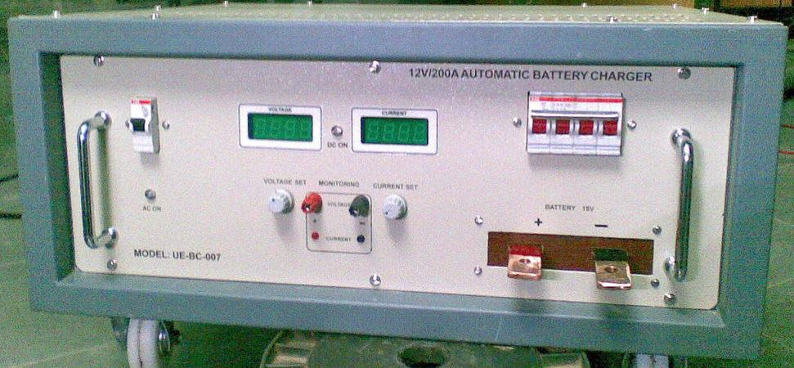

SPECIFICATIONS FOR 12V/200A BATTERY CHARGER

1. Model no : UE-BC-007.

2. Mains input : 230V, ±10%, 50Hz, Single phase.

3. Line Regulation : ±0.1% max. Output Voltage for ± 10% change
in mains Input Voltage.

4. Load Regulation : ±0.1% max. Output Voltage for No-load
to full load or Vice-versa.

5. Ripple : Less than 100mV R.M.S.

6. Protections : a) Unit is protected by input fuse,
b) Unit is protected against input surges,
c) Output is protected against over loads &
Continuo’s short circuits.

7. Indication(s) : a) One LED for input,
b) One LED each for output,
c) One 3½ digit digital panel meter is
provided to read output voltage,
d) One 3½ digit digital panel meter is
provided to read output current.

8. Controls : One ON/OFF switch to ON/OFF the Unit.

9. Mechanical : Bench top / 19” Rack Mounting as
required by you.

10. Cooling : Forced air cooling.

11. Operating Environment : 0°C to +50°C

12. Terminals : Banana socket(s) at front panel .

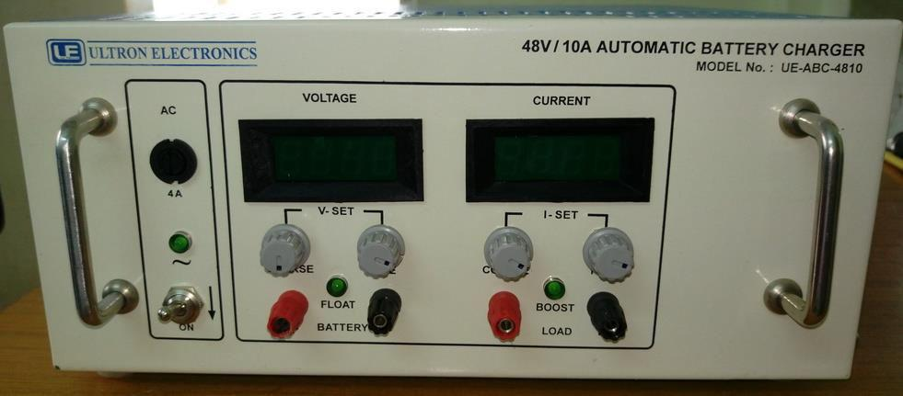

SPECIFICATIONS FOR 48V/10A BATTERY CHARGER

1. Model no : UE-ABC-4810.

2. Mains input : 230V, ±10%, 50Hz, Single phase.

3. Line Regulation : ±0.1% max. Output Voltage for ± 10% change
in mains Input Voltage.

4. Load Regulation : ±0.1% max. Output Voltage for No-load
to full load or Vice-versa.

5. Ripple : Less than 100mV R.M.S.

6. Protections : a) Unit is protected by input fuse,
b) Unit is protected against input surges,
c) Output is protected against over loads &
Continuous short circuits.

7. Indication(s) : a) One LED for input,
b) One LED each for output,
c) One 3½ digit digital panel meter is
provided to read output voltage,
d) One 3½ digit digital panel meter is
provided to read output current.

8. Controls : One ON/OFF switch to ON/OFF the Unit.

9. Mechanical : Bench top / 19” Rack Mounting as
required by you.

10. Cooling : Forced air cooling.

11. Operating Environment : 0°C to +50°C

12. Terminals : Banana socket(s) at front panel .

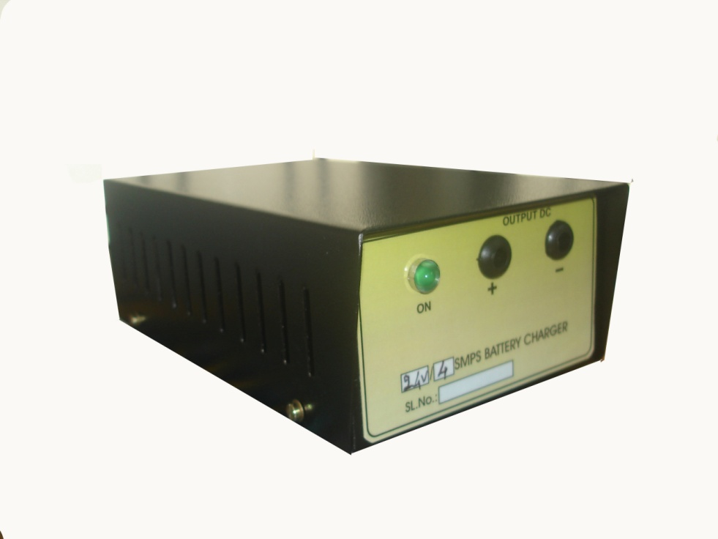
SPECIFICATIONS FOR 24V/4A SMPS BATTERY CHARGER

1. Model no : .

2. Mains input : 230V, ±10%, 50Hz, Single phase.

3. Line Regulation : ±0.1% max. Output Voltage for ± 10% change
in mains Input Voltage.

4. Load Regulation : ±0.1% max. Output Voltage for No-load
to full load or Vice-versa.

5. Ripple : Less than 100mV R.M.S.

6. Protections : a) Unit is protected by input fuse,
b) Unit is protected against input surges,
c) Output is protected against over loads &
Continuous short circuits.

7. Indication(s) : a) One LED for input,
b) One LED each for output,
c) One 3½ digit digital panel meter is
provided to read output voltage,
d) One 3½ digit digital panel meter is
provided to read output current.

8. Controls : One ON/OFF switch to ON/OFF the Unit.

9. Mechanical : Bench top / 19” Rack Mounting as
required by you.

10. Cooling : Forced air cooling.

11. Operating Environment : 0°C to +50°C

12. Terminals : Banana socket(s) at front panel .

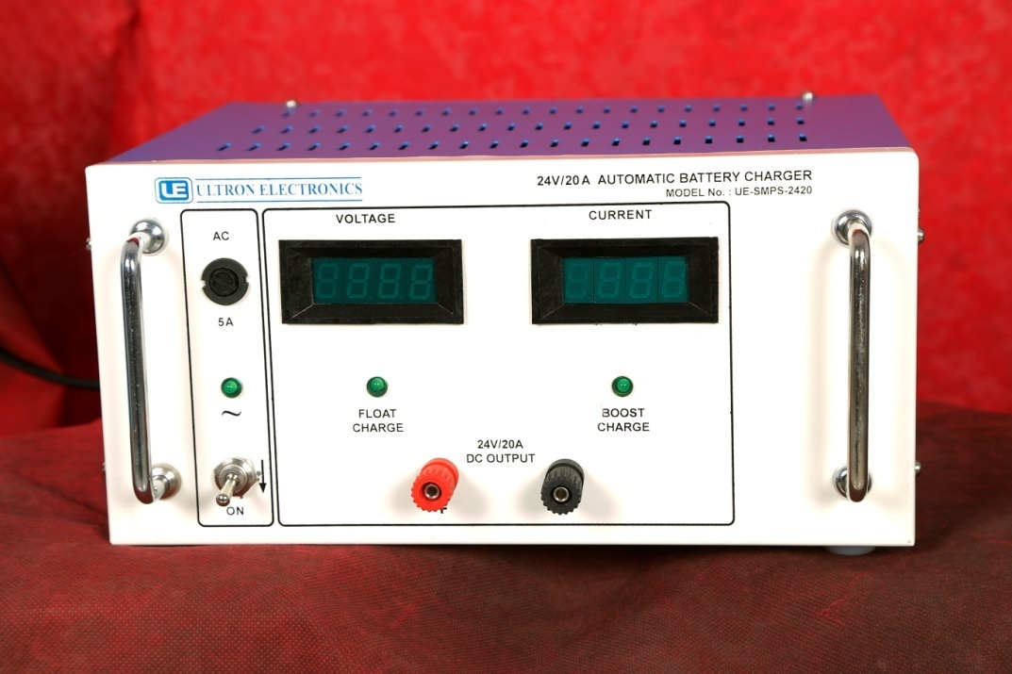

SPECIFICATIONS FOR 24V/20A BATTERY CHARGER

1. Model no : UE-SMPS-2420.

2. Mains input : 230V, ±10%, 50Hz, Single phase.

3. Line Regulation : ±0.1% max. Output Voltage for ± 10% change
in mains Input Voltage.

4. Load Regulation : ±0.1% max. Output Voltage for No-load
to full load or Vice-versa.

5. Ripple : Less than 100mV R.M.S.

6. Protections : a) Unit is protected by input fuse,
b) Unit is protected against input surges,
c) Output is protected against over loads &
Continuous short circuits.

7. Indication(s) : a) One LED for input,
b) One LED each for output,
c) One 3½ digit digital panel meter is
provided to read output voltage,
d) One 3½ digit digital panel meter is
provided to read output current.

8. Controls : One ON/OFF switch to ON/OFF the Unit.

9. Mechanical : Bench top / 19” Rack Mounting as
required by you.

10. Cooling : Forced air cooling.

11. Operating Environment : 0°C to +50°C

12. Terminals : Banana socket(s) at front panel.

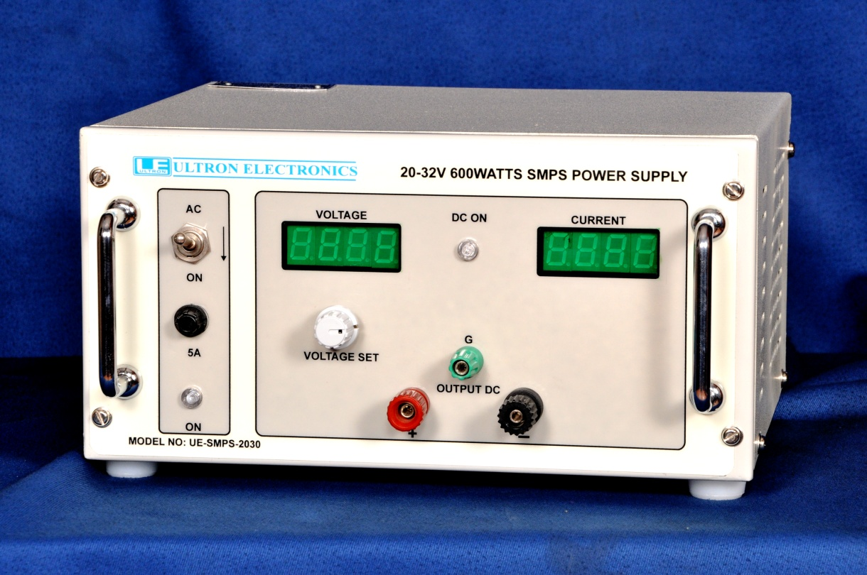
.

SPECIFICATIONS FOR 20-32V/600WATTS SMPS POWER SUPPLY

1. Model no : UE-SMPS-2030.

2. Mains input : 230V, ±10%, 50Hz, Single phase.

3. Line Regulation : ±0.1% max. Output Voltage for ± 10% change
in mains Input Voltage.

4. Load Regulation : ±0.1% max. Output Voltage for No-load
to full load or Vice-versa.

5. Ripple : Less than 100mV R.M.S.

6. Protections : a) Unit is protected by input fuse,
b) Unit is protected against input surges,
c) Output is protected against over loads &
Continuous short circuits.

7. Indication(s) : a) One LED for input,
b) One LED each for output,
c) One 3½ digit digital panel meter is
provided to read output voltage,
d) One 3½ digit digital panel meter is
provided to read output current.

8. Controls : One ON/OFF switch to ON/OFF the Unit.

9. Mechanical : Bench top / 19” Rack Mounting as
required by you.

10. Cooling : Forced air cooling.

11. Operating Environment : 0°C to +50°C

12. Terminals : Banana socket(s) at front panel.

